*Junhyun Lee*

Montgomery Academy

Sponsor: Mrs. Gleason

*Level*

*Category*

*Project Type*

Region 5

Table of Contents

Narrative . . . . . . . . . . . . . . . . . . . . . . . . . . . . . . . . . 3

URL . . . . . . . . . . . . . . . . . . . . . . . . . . . . . . . . . . . . 17

Resources . . . . . . . . . . . . . . . . . . . . . . . . . . . . . . . 18

Project Code . . . . . . . . . . . . . . . . . . . . . . . . . . . . . 19

Works Cited . . . . . . . . . . . . . . . . . . . . . . . . . . . . . .20

Epilogue . . . . . . . . . . . . . . . . . . . . . . . . . . . . . . . . .21

Narrative

Why I went to create this program:

I wanted to make a full-stack application that will interact with MySQL database using REST APIs made with Spring Boot which will incorporate all the skills that I learned into one program.

How I created it:

Also, I noticed a lack of good tools for regular people to pick and choose PC components for their new PC. They often had to open multiple browser tabs in websites like newegg.com to keep the components they wanted or use inconvenient and not intuitive interfaces for PC building setup such as shopping carts in online shopping.

First, I created a new MySQL database with different tables representing different PC component types (ex., processors, graphics cards, RAMs, etc.). Each table has four columns representing the component's name, price, link to the product image in newegg.com, and product detail page in newegg.com.

Second, I created a python program that uses the Beautiful Soup 4 library that queries all PC components on each PC component's type available in newegg.com and stores them into each separate table in the MySQL database. The program will repeat this querying process every 3 hours to update product information on newegg.com.

Third, I created a REST API service using Spring Boot framework with Spring Boot JDBC dependency to make the server on the MySQL database respond to GET requests that the frontend JavaScript interface sends. When the frontend program sends a GET request to a specific URL, the Spring Boot program picks it up and calls functions in the JDBC dependency. The functions execute MySQL query on the database and forwards queried data to the Spring Boot program, and the Spring Boot program forwards data again to the frontend.

After creating the backend, I made the frontend, a desktop app made with JavaScript and electron.js. It has two primary windows, the main window for showing inserted PC components, showing all the components in newegg.com, and inserting PC components to the user's build setup.

The app’s functionality:

The user can click the "add component" button in the main window to make a new pop-up window. Then the user can choose a category of PC components (processors, motherboard, RAM, etc.) which will display all the components available on that component category in the window. This is accomplished by sending a GET request to the server, requesting a list containing all of the component category's component data. The Spring Boot service in the server responds with requested data stored in the MySQL database. The frontend desktop app renders and displays the data received from the server in the pop-up window created before the button was clicked. The user can also remove an added component from the main window by double clicking at the added component block. When the selected component is added/removed in the main window, the price of every component is automatically added/subtracted and the cumulative price of the build setup is displayed.

The main window

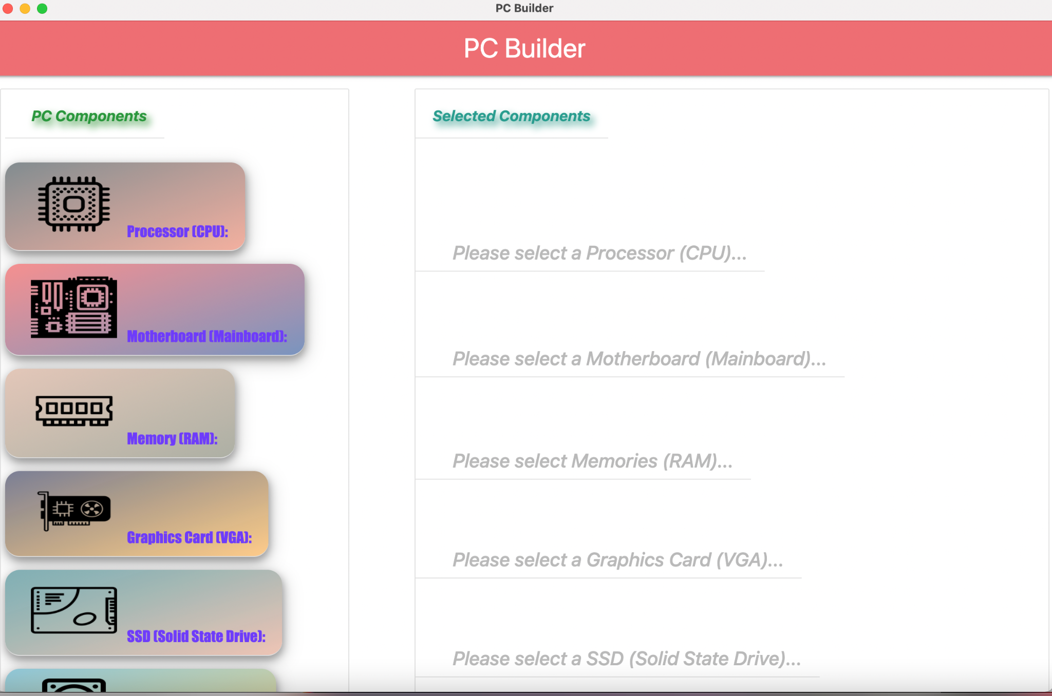

The pop-up window (for adding new components)

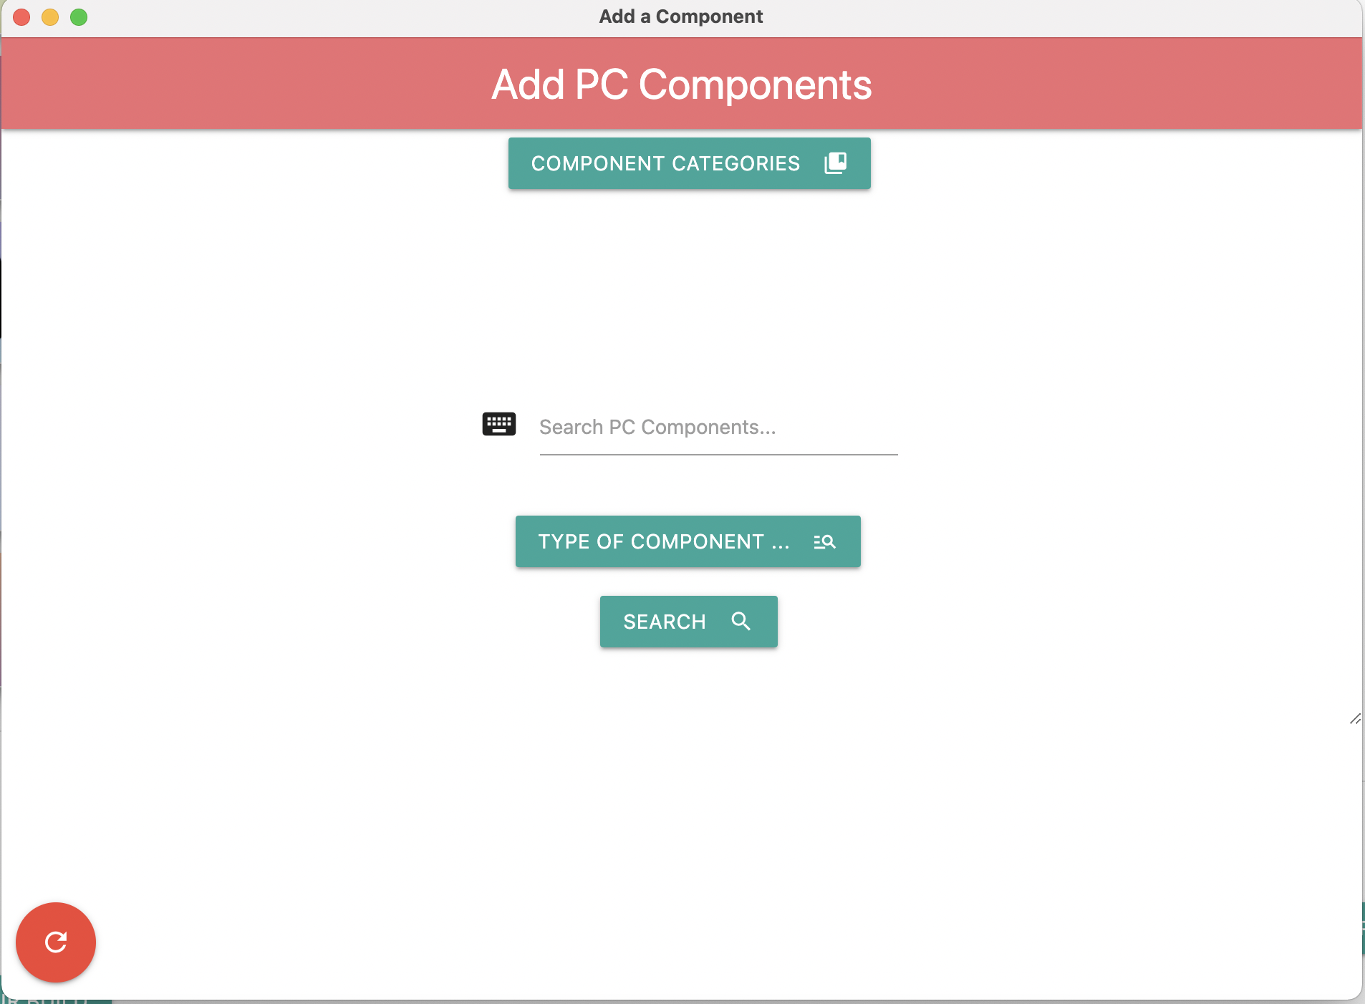

The dropdown menu pops up when the user clicks the “Component Categories” button for choosing the component category.

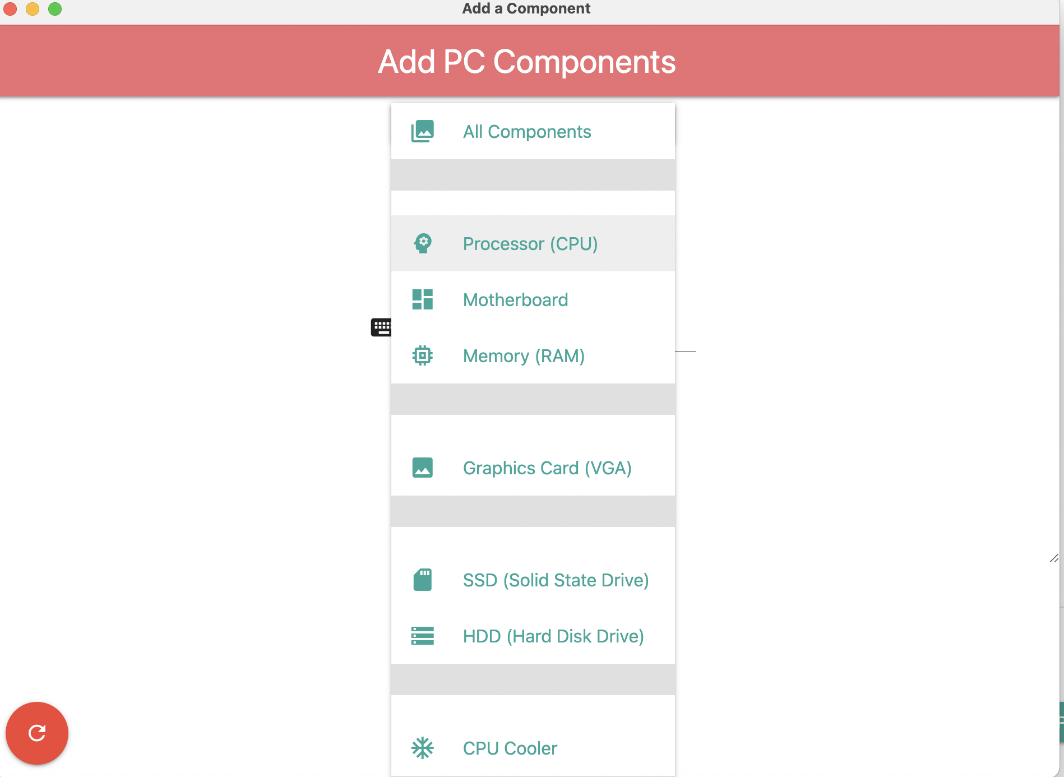

When the user clicks a certain category, the program displays the list representing all the available components on newegg.com of the category.

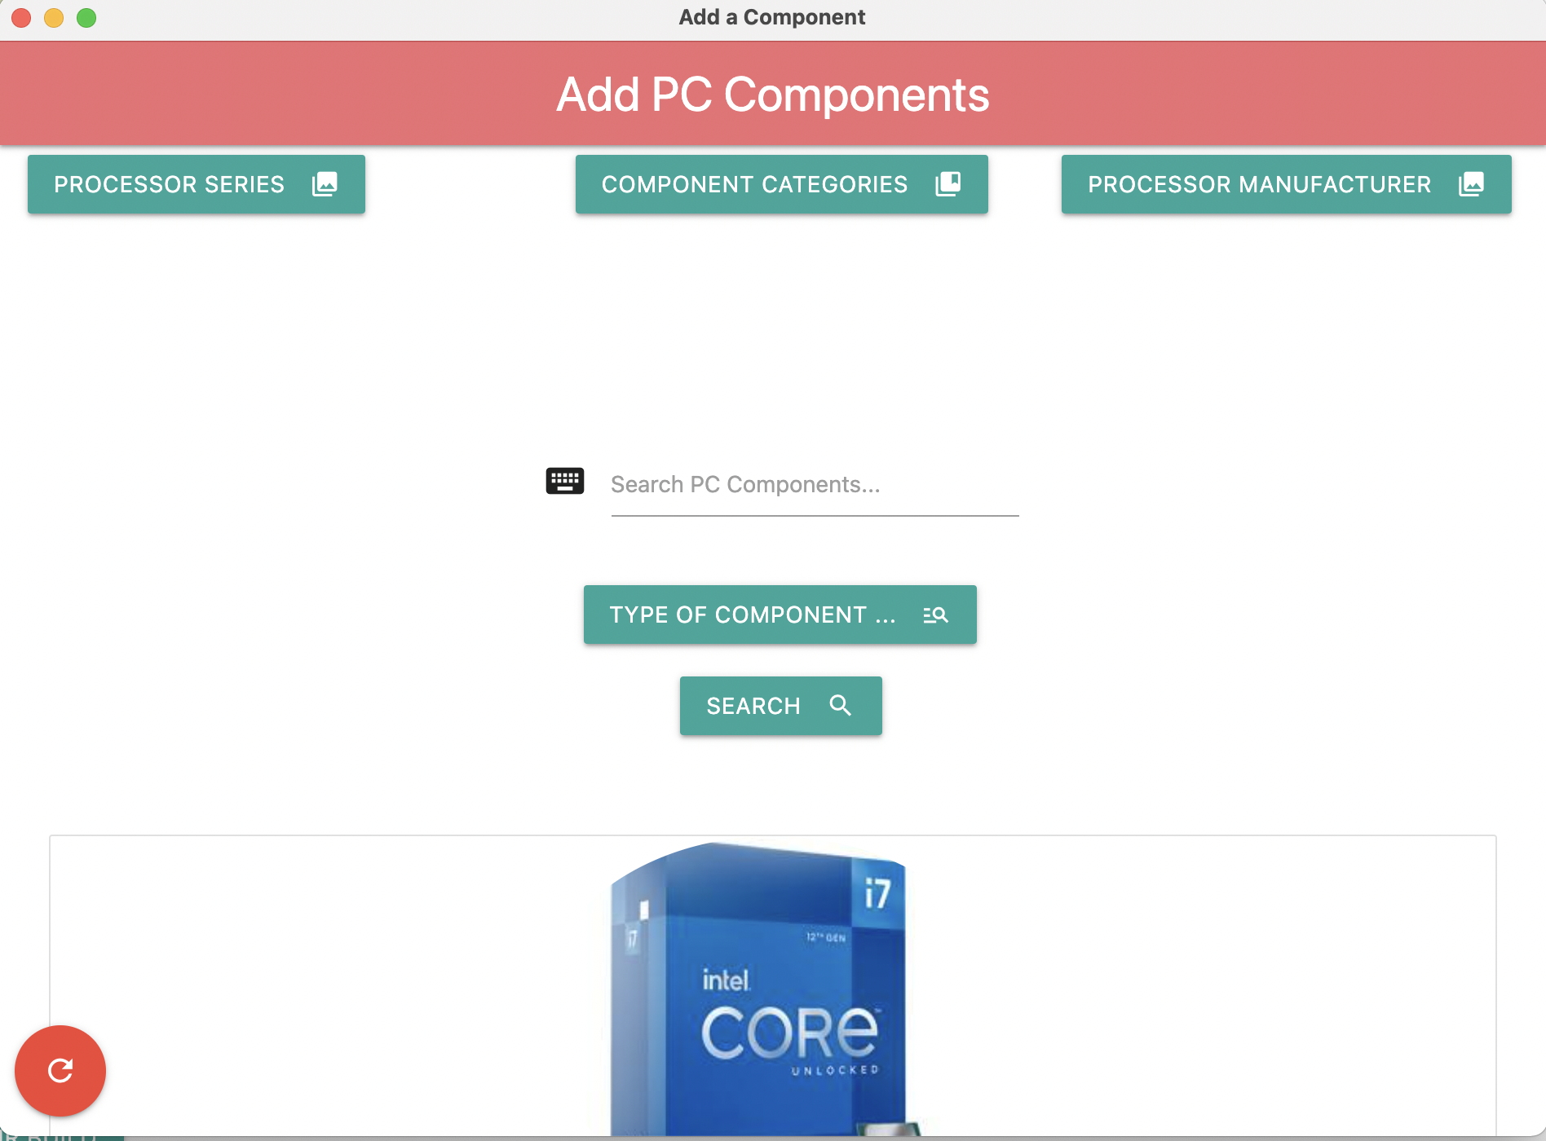

When the user clicks one of the shopping cart icons on the list of the rendered information of PC components in the window, the corresponding component of that shopping cart icon is inserted into the main window in the correct row with each banner representing each component type according to its component categories. This is done by an electron passing the component information of the pop-up window to the main window using IPC (inter-process communication), a method of transferring information between two processes.

The Shopping Cart Icon transfers the component data of the selected component to the main window in the corresponding row. (enables selection of components)

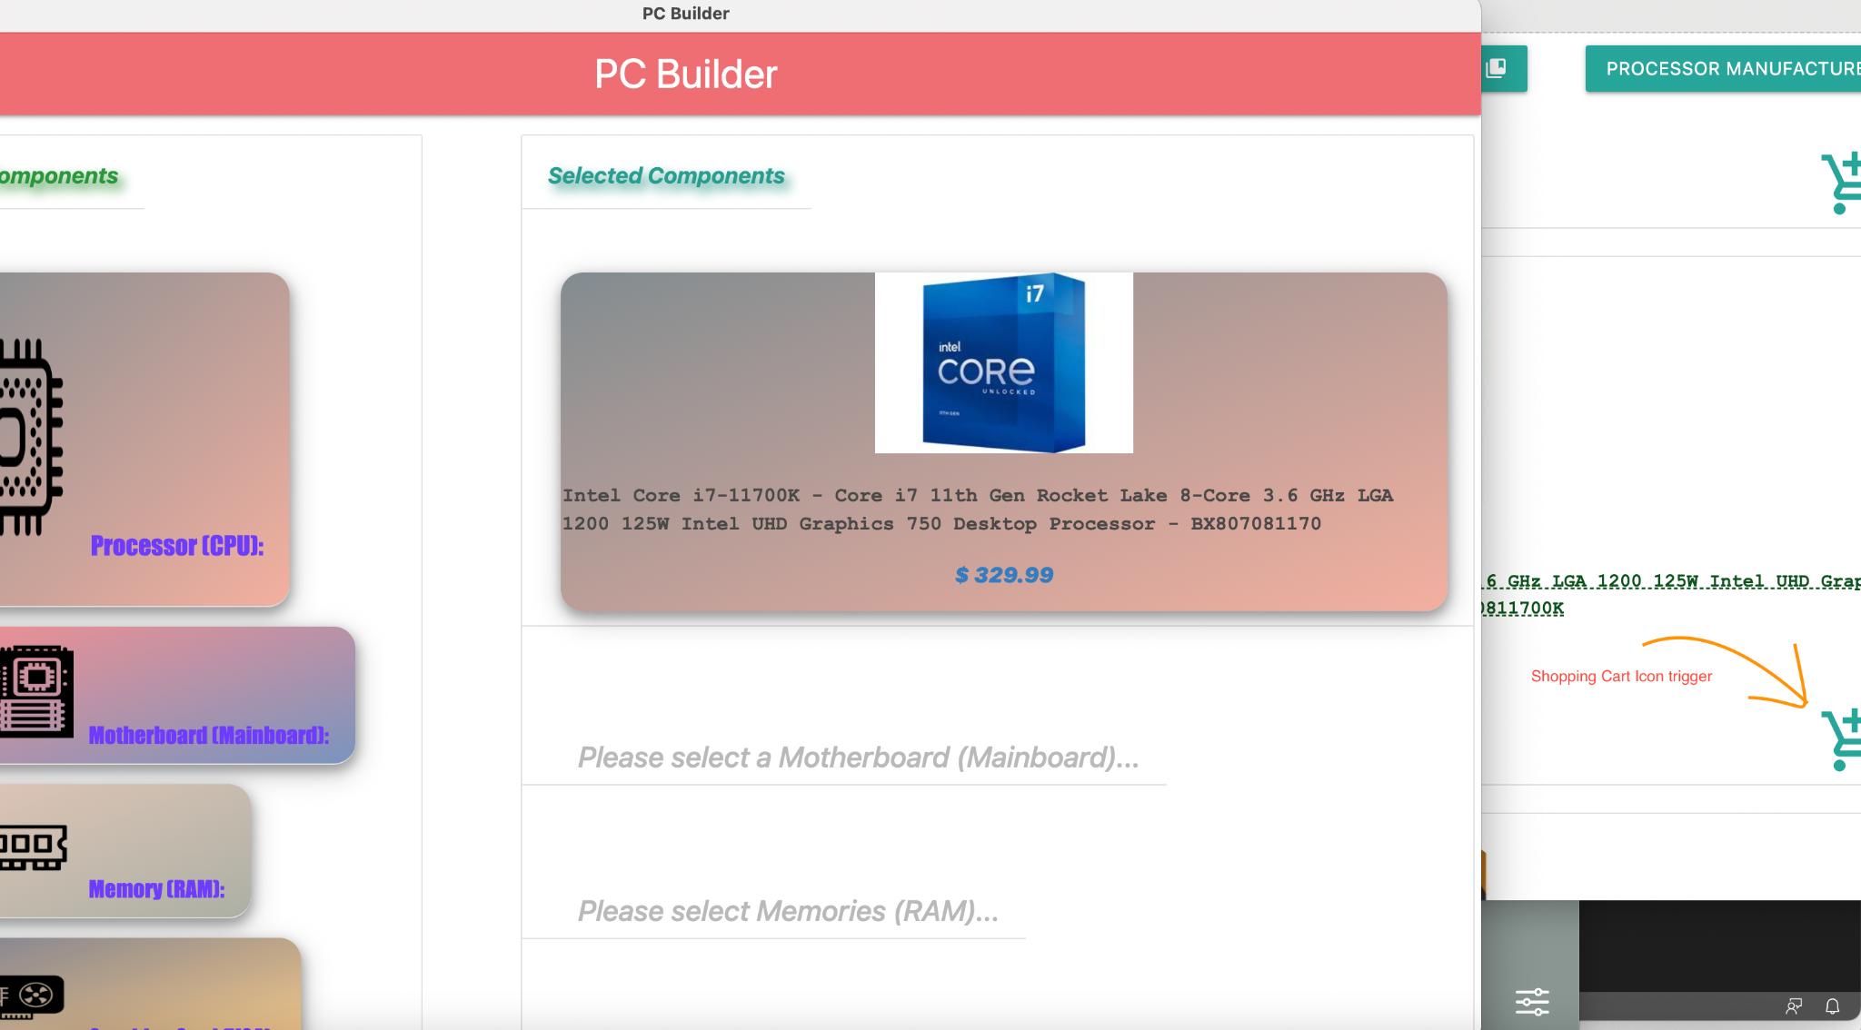

The cumulative price of the components added are automatically calculated after each component selection.

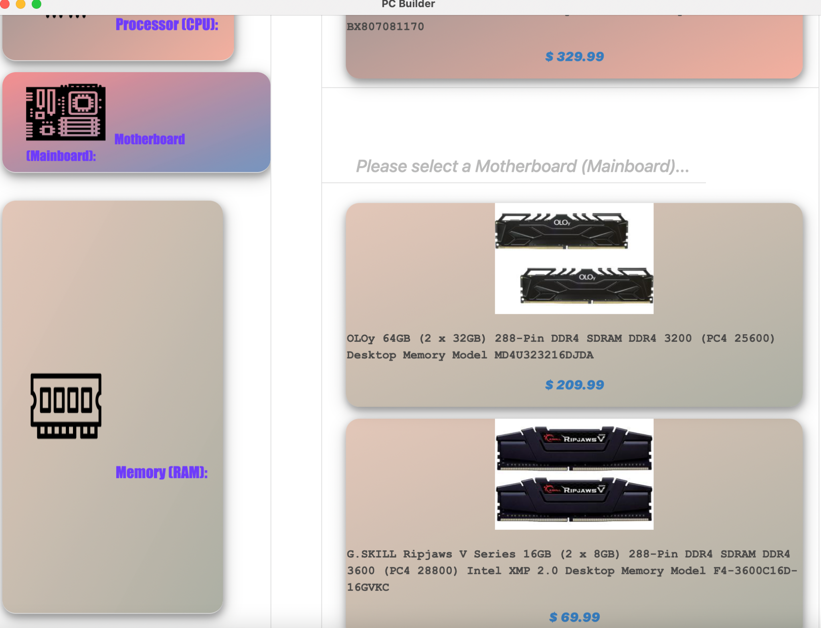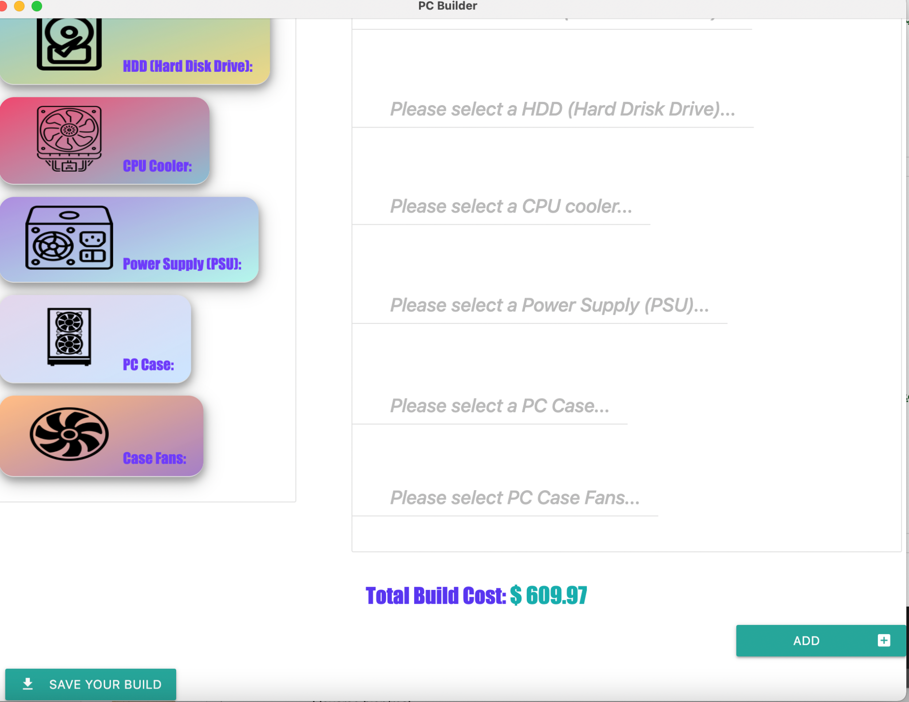

The user can also search for a specific component by entering the component's name the user wants to search and the scope of the search by the component category. Also, some components have subcategories that can further filter down the component the user wants by specific criteria (ex., Motherboard chipset, manufacturer, etc.) These are also done by sending another GET request to the server, which will respond with a list of components that match specific criteria or strings.

The user can enter the string to search.

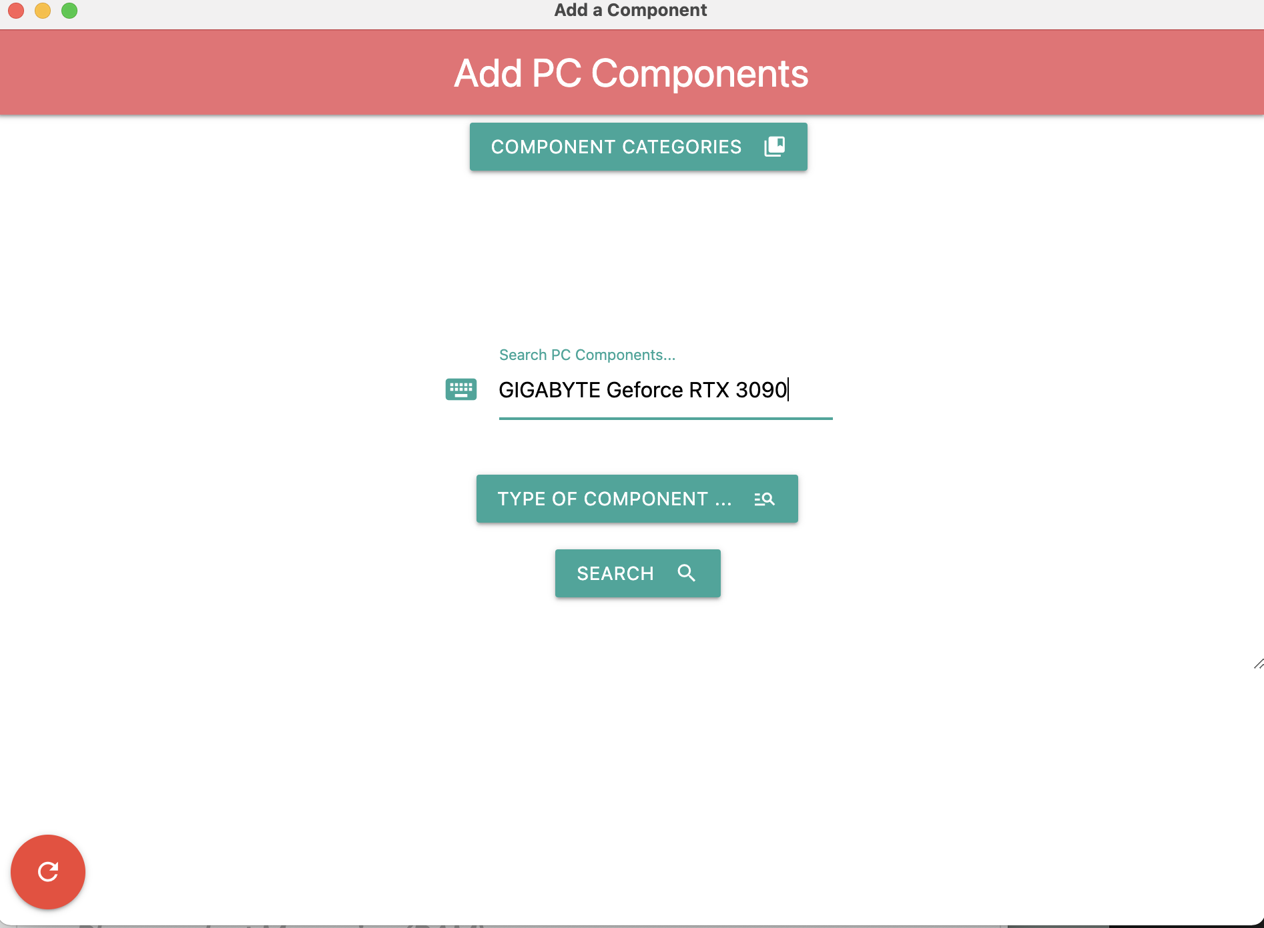

The user can select the category of the component to search for.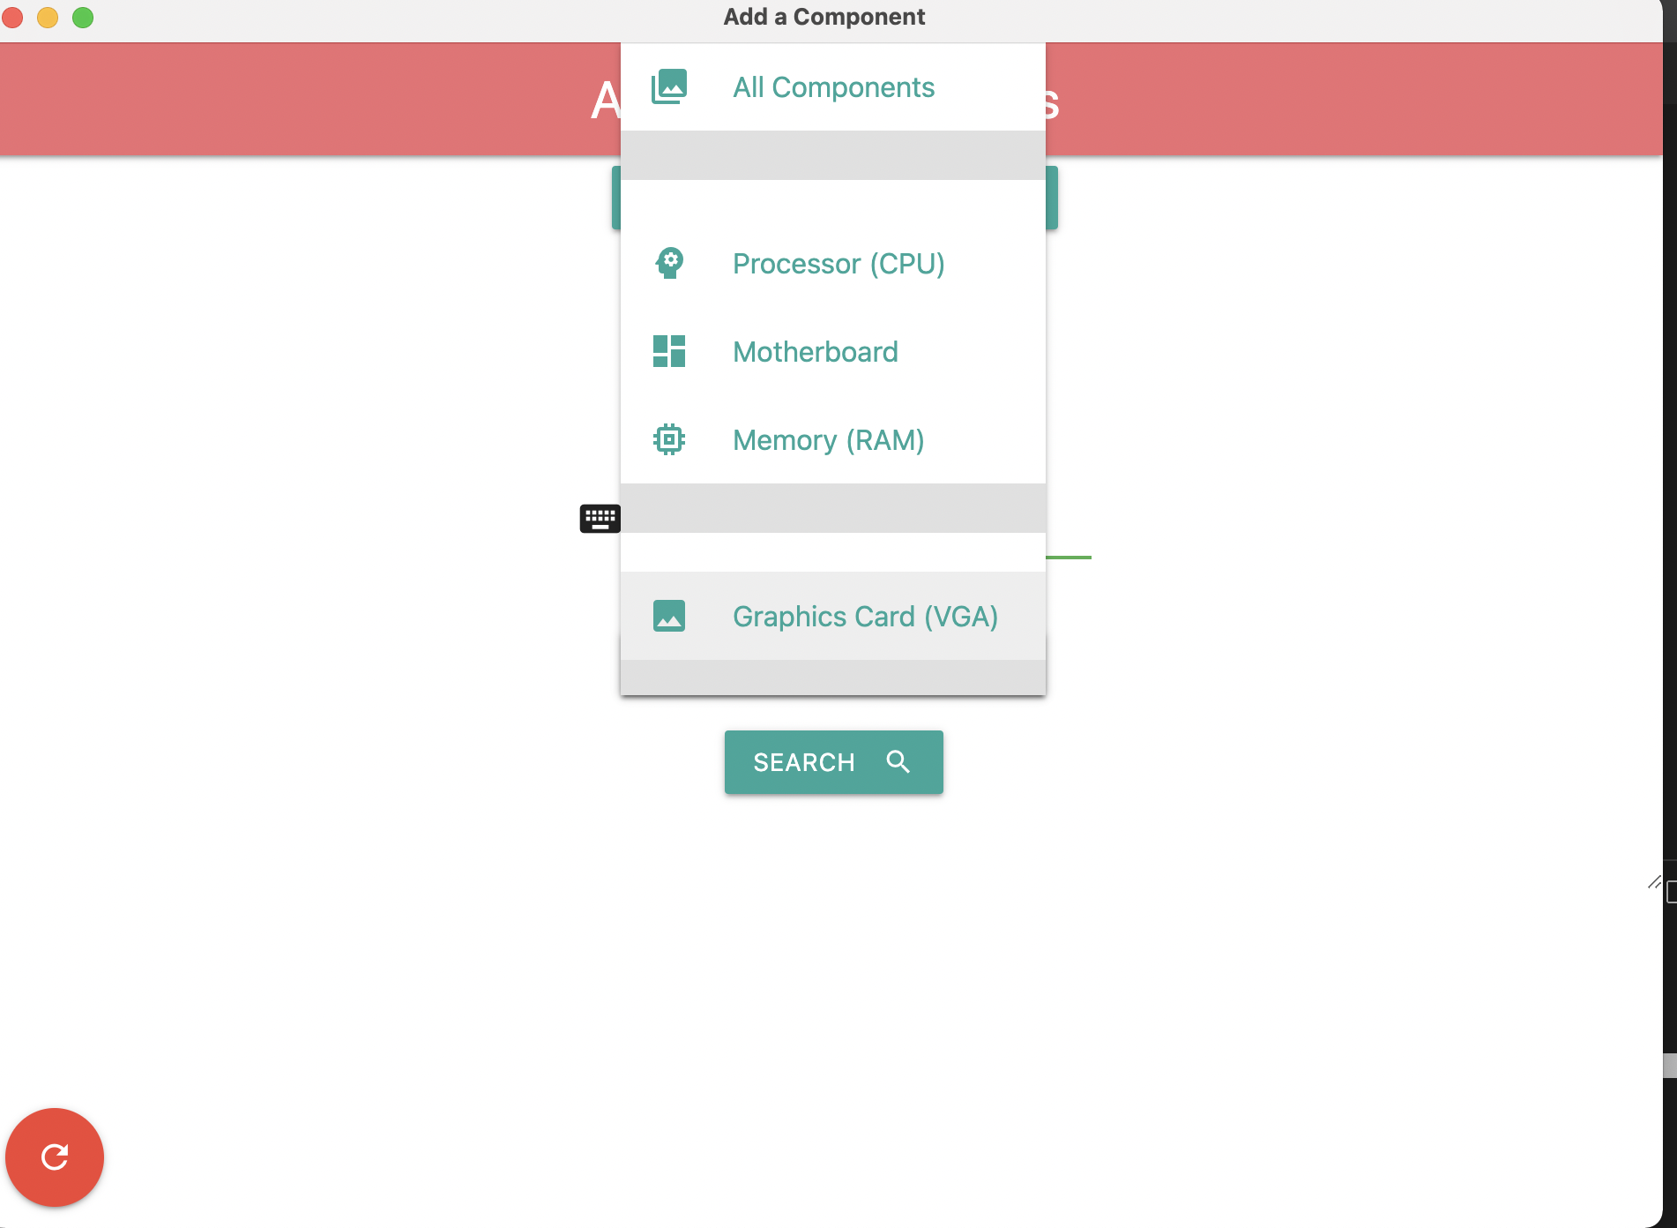

When the user clicks the search button, the program will display the list of components that match the search result.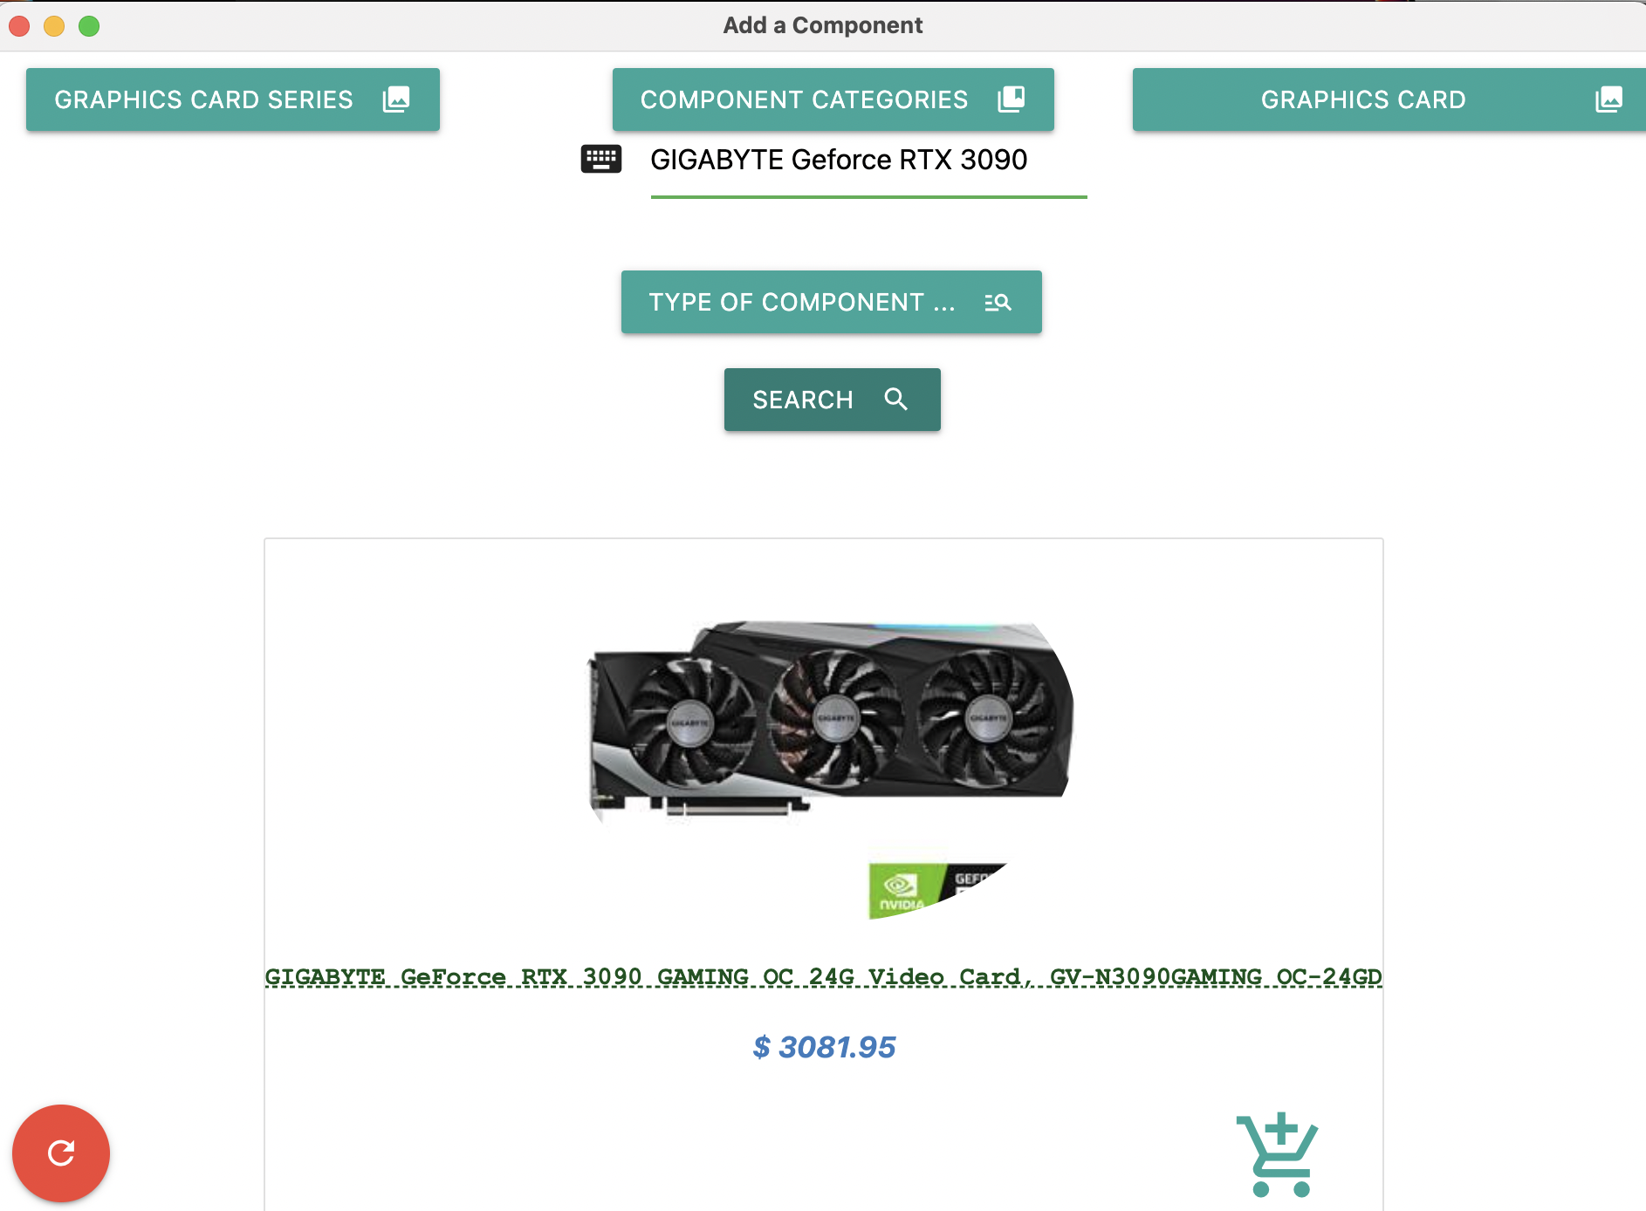

When users complete their build setup of a new PC, they can save that setup indefinitely after the frontend app terminates by exporting the setup to CSV, HTML, or PDF files. The CSV string form is made every time the user inserts a new component to the main window, and when the user triggers the button to export it, the program makes the form into a file and asks the user to download the exported file. When the user exports the setup to HTML, it queries the HTML code section from the body to the end of the last component section row. Then, the program makes the queried code to a file and asks the user to download the file. When the user exports the setup to PDF, two setup formats are exported to the PDF. The first way is to query every name of the added component in the main window and insert it into the PDF file. The second way is to export the whole-body section of the HTML code to the PDF file. After that, the program asks a user to download the exported file.

There are buttons for export options of the build setup both in the menu bar and main window.

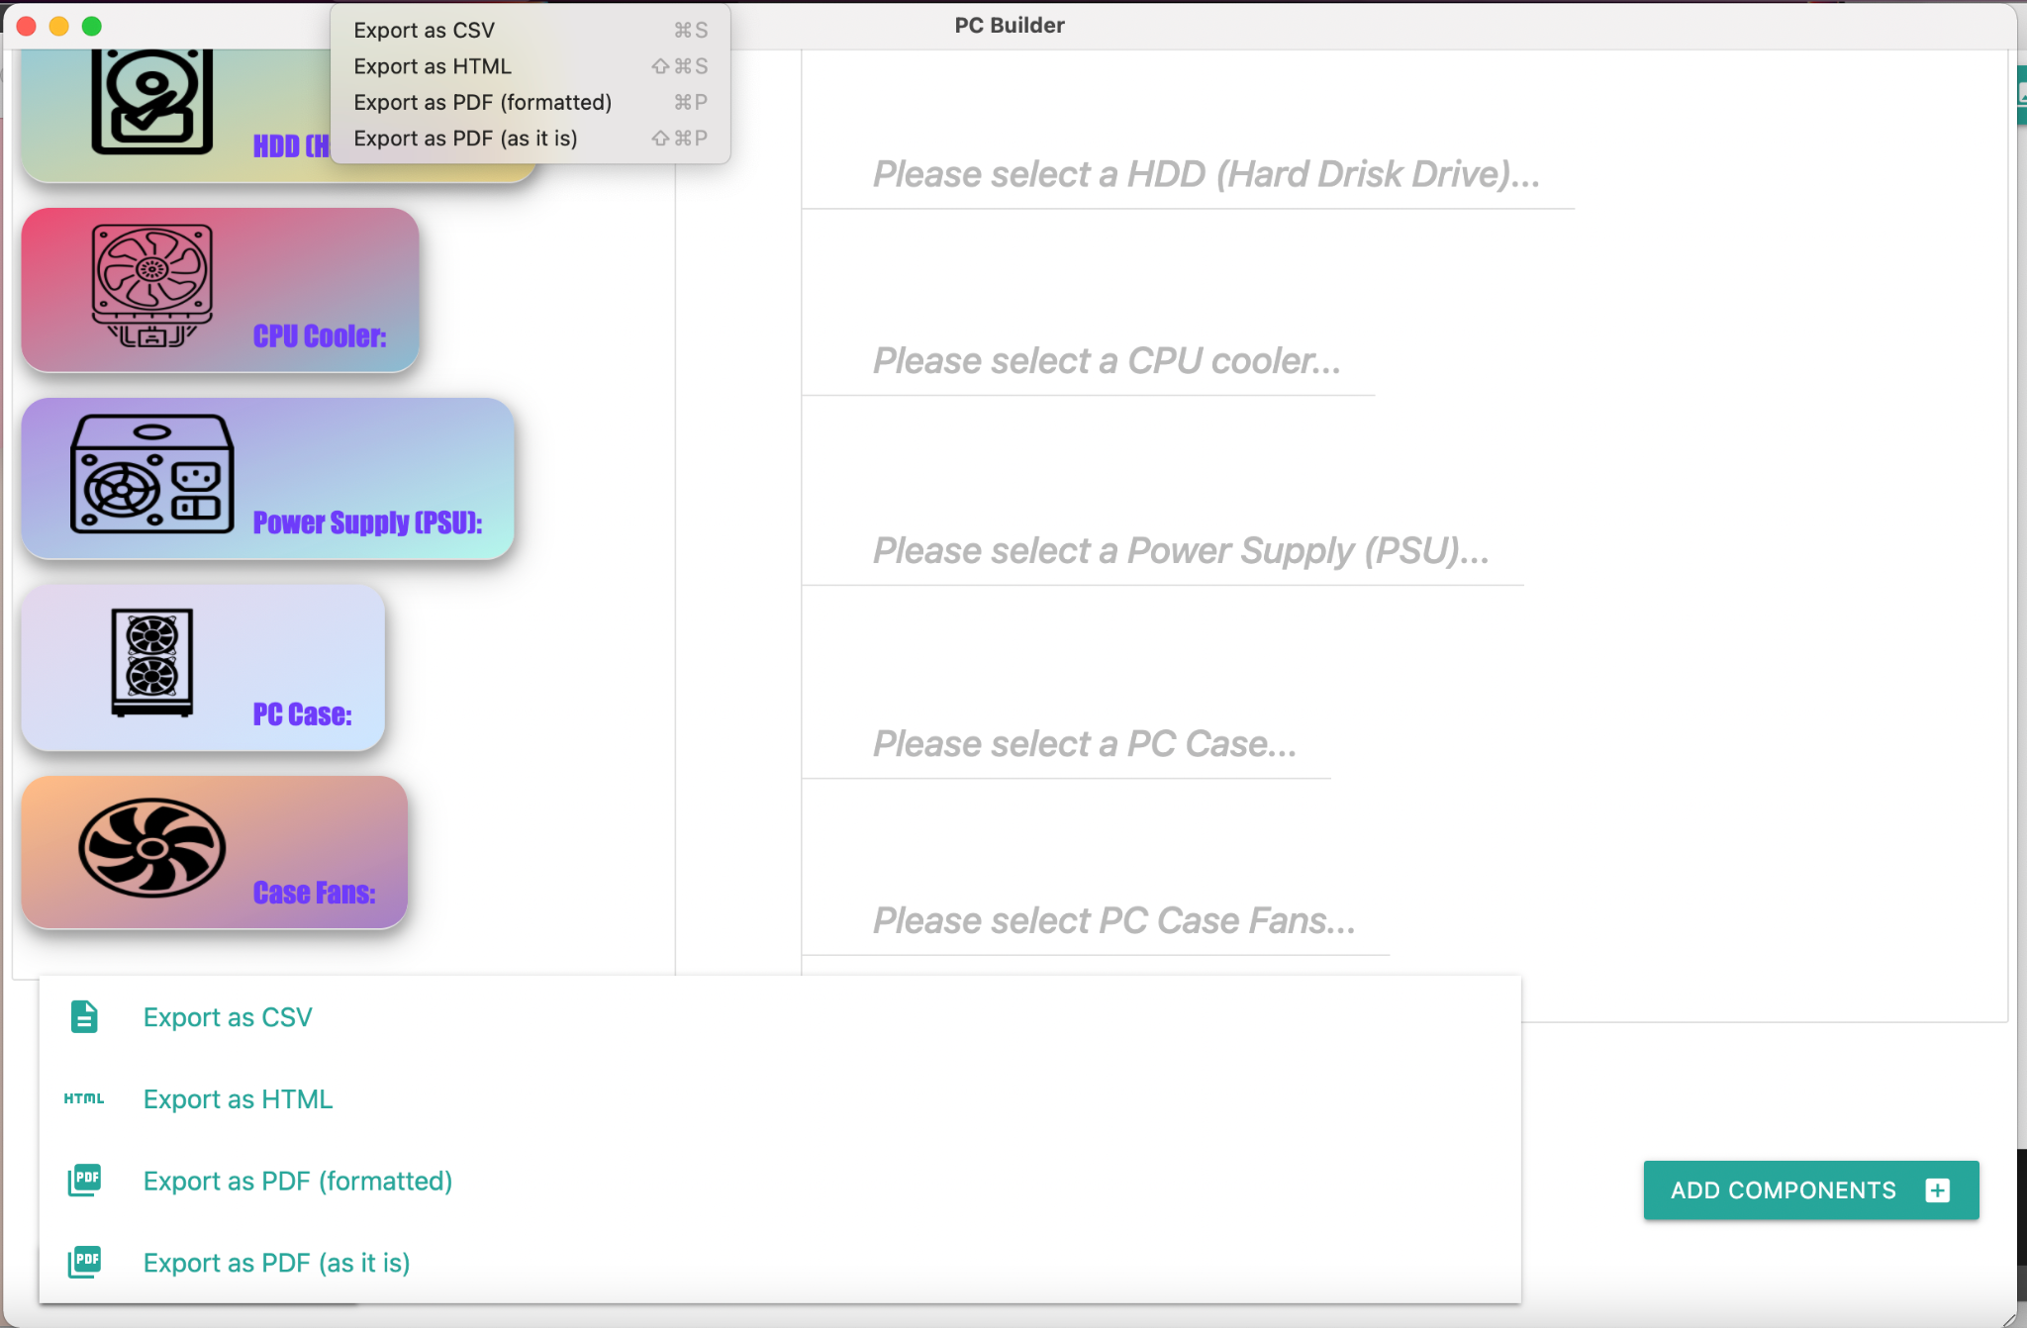

PDF export of the build when exported as “Export as PDF (as it is)”

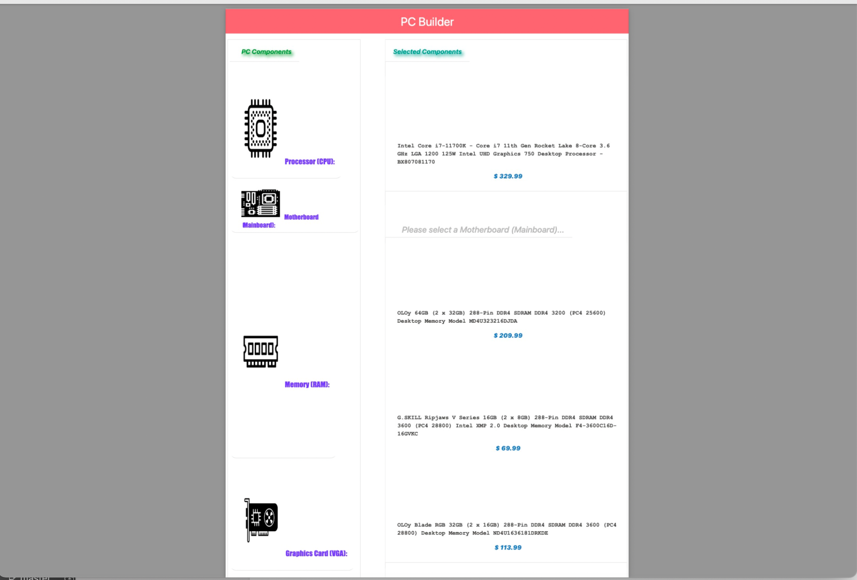PDF export of the build when exported as “Export as PDF (formatted)”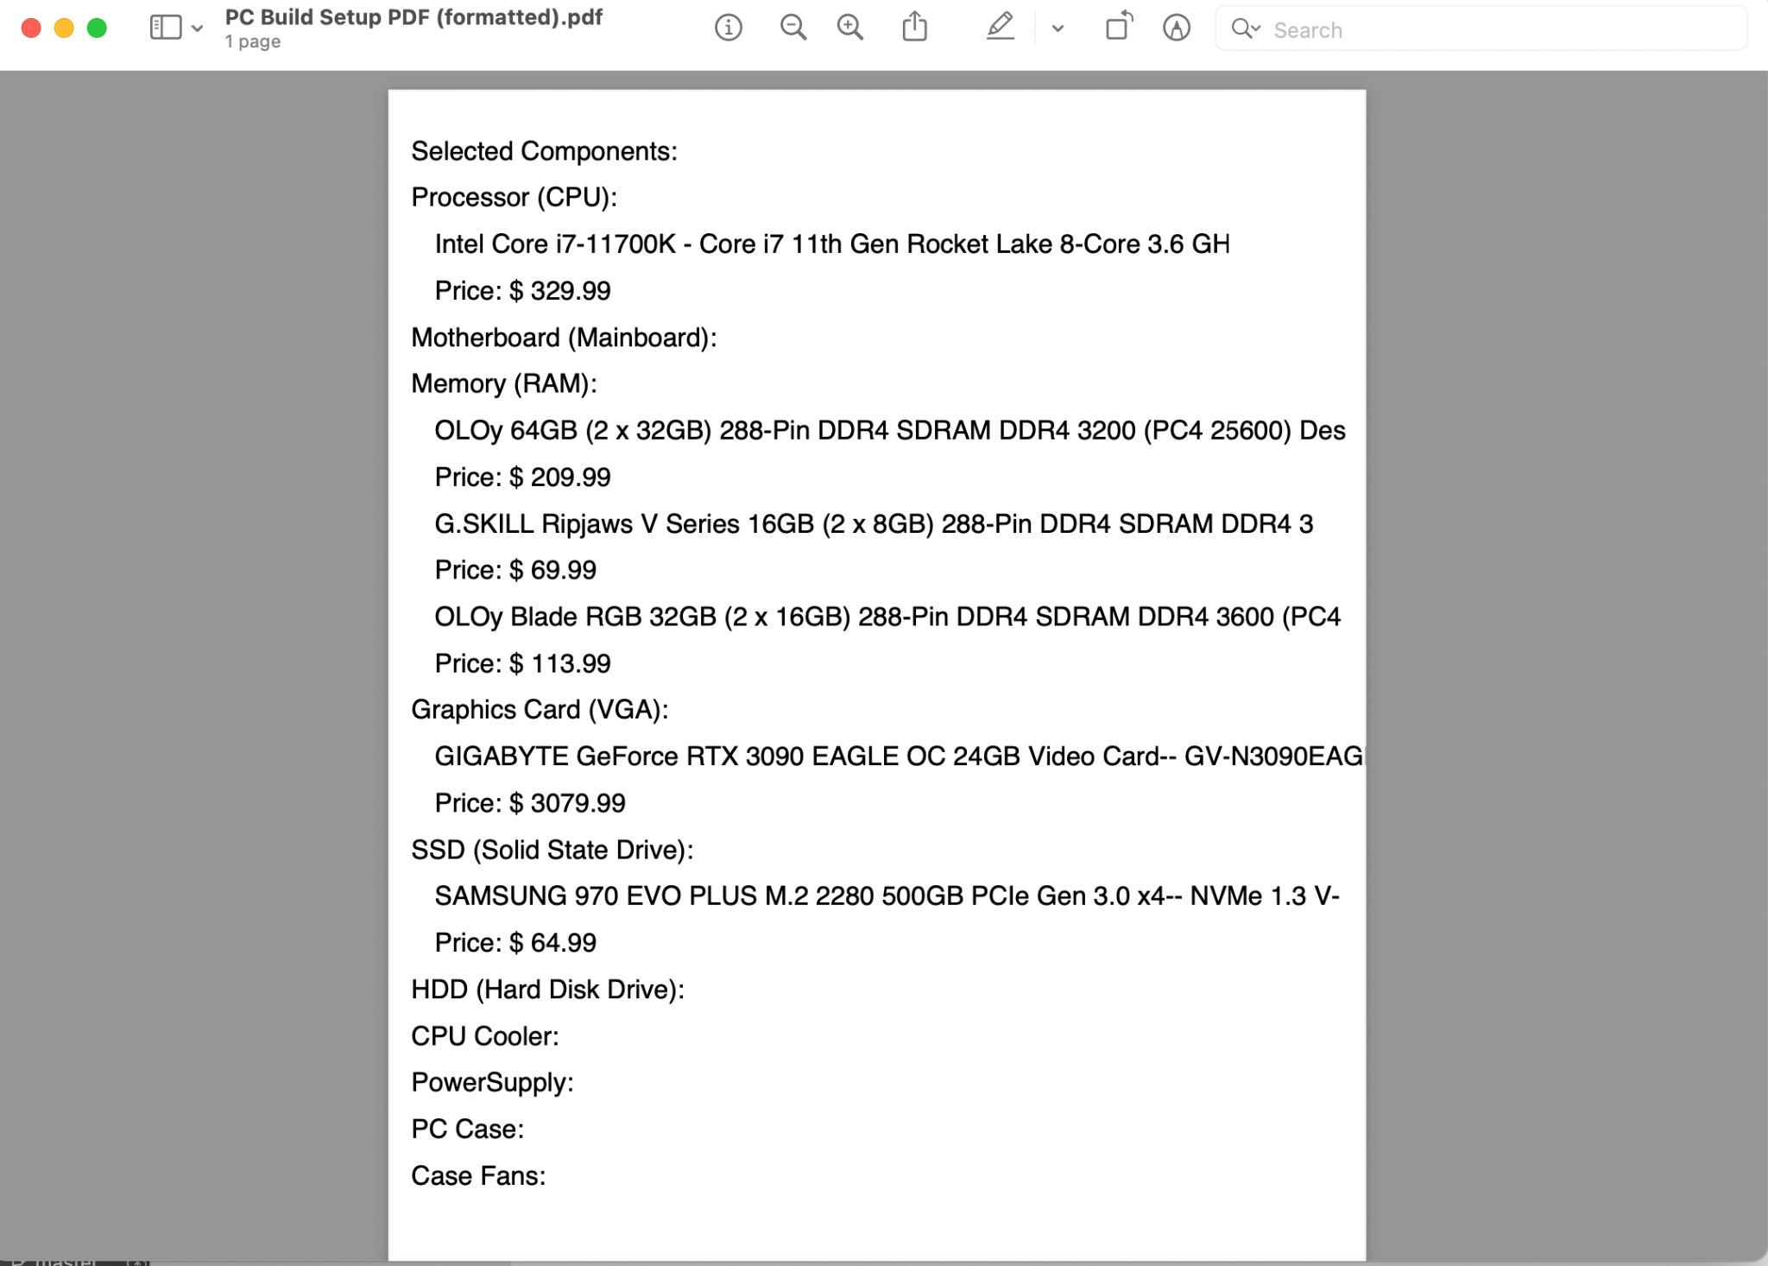PDF export of the build when exported as “Export as HTML”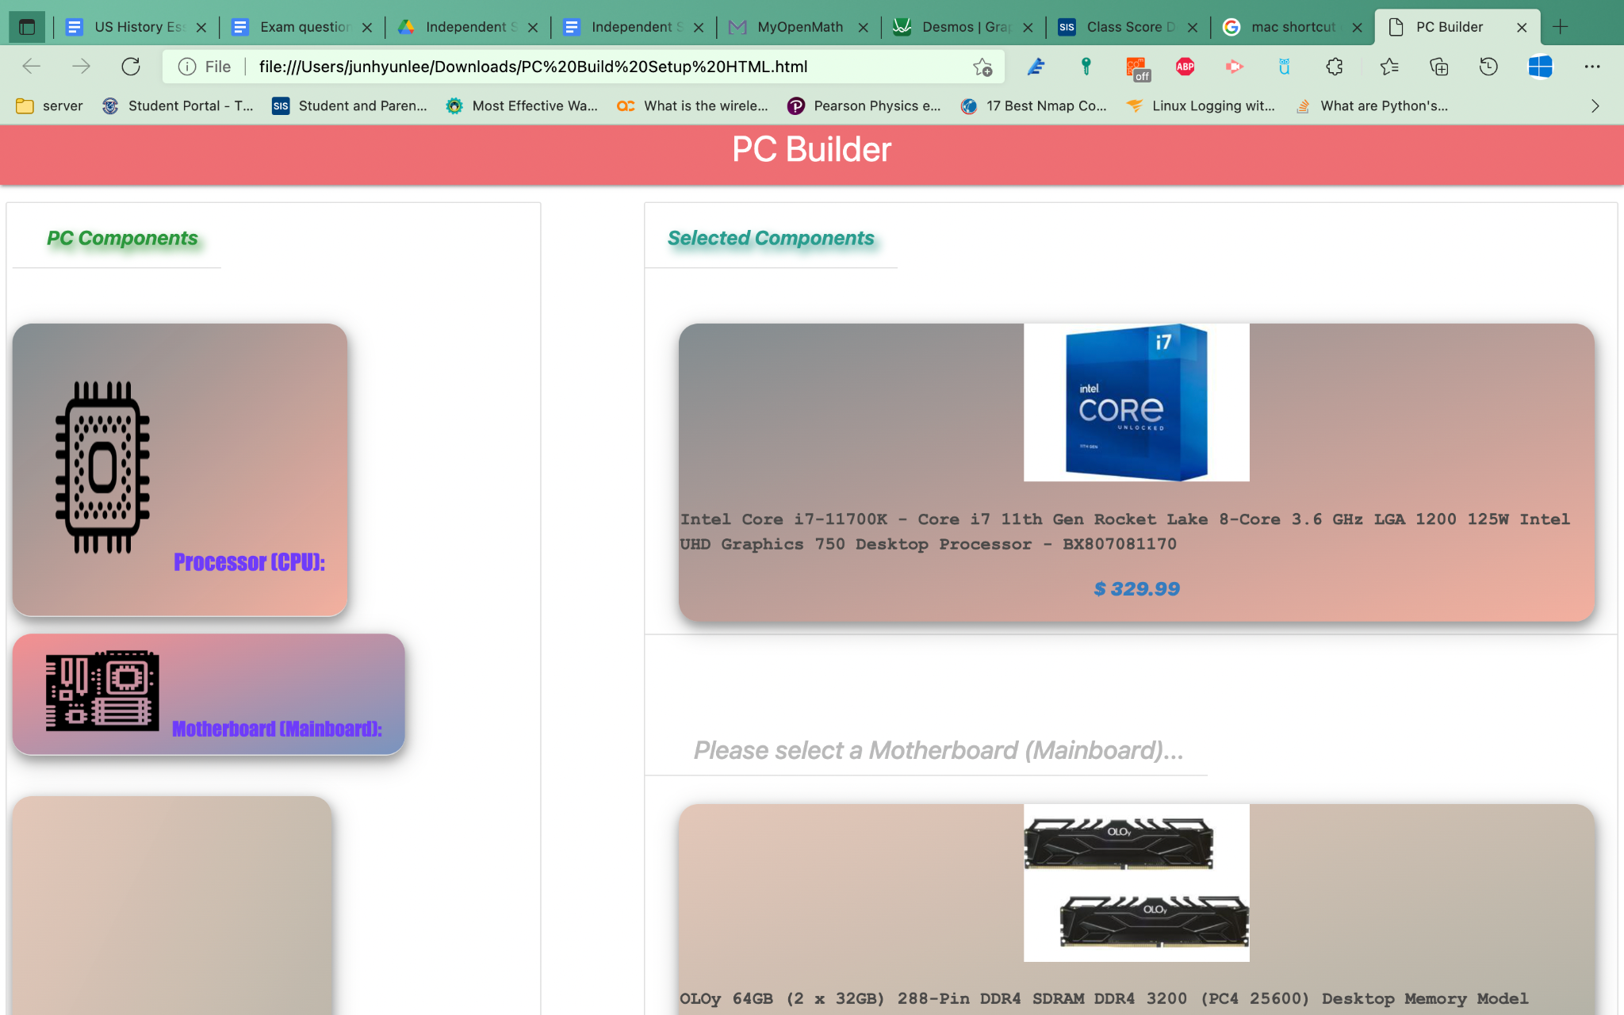PDF export of the build when exported as “Export as CSV”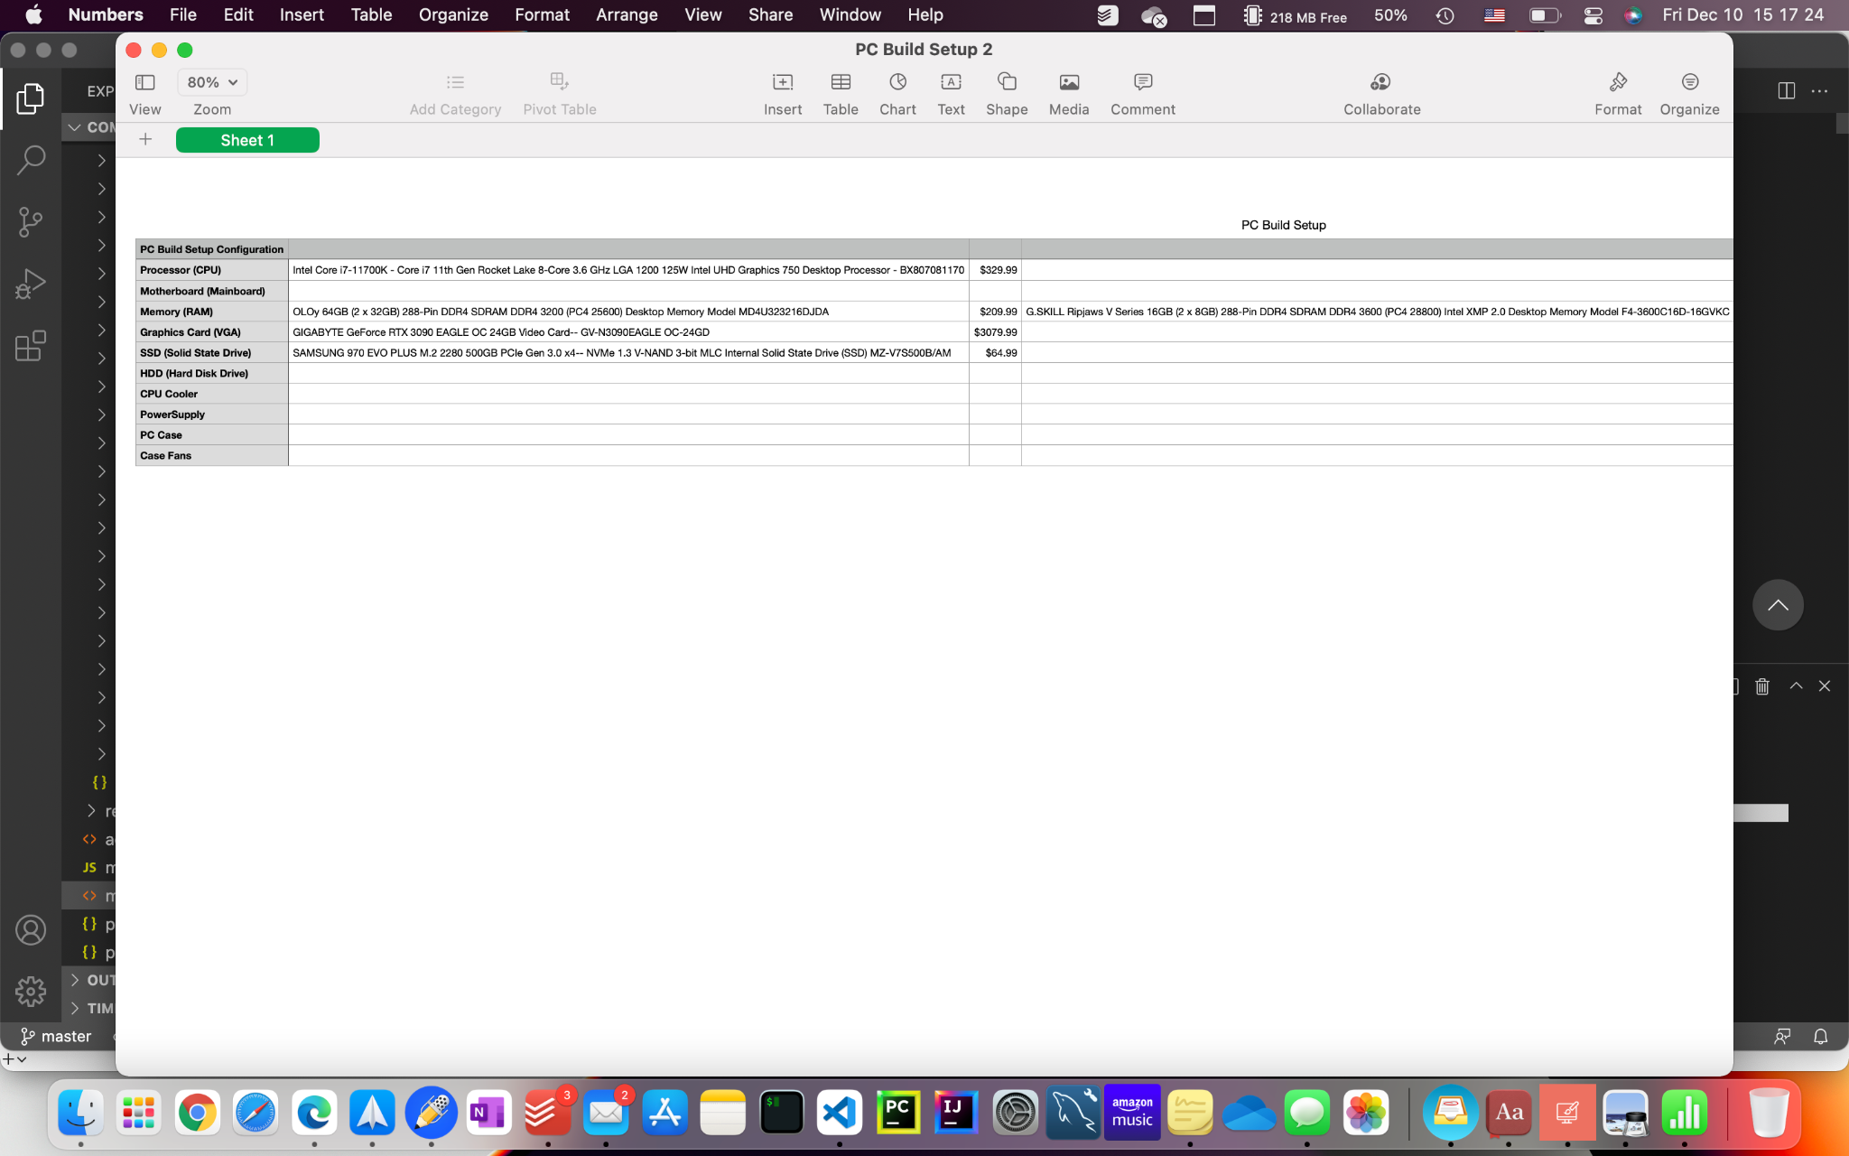

Video URL

https://drive.google.com/file/d/1F3khTaQhT8fJQ7lHwOLjJj5iSK2HqCor/view?usp=sharing

Resources

IntelliJ Idea

PyCharm

Visual Studio Code

EC2 AWS instance

MySQL database

MYSQL workbench

Electron.js

jsPDF

jQuery

Materialize CSS framework

Beautiful Soup 4 (BS4)

Project Code

Python querying program: <https://drive.google.com/drive/folders/1IRKRJ4m1tovJJbH615MYK-U-VqvcxF7N?usp=sharing>

REST API service program:

<https://drive.google.com/drive/folders/1UVbY_MVPwOZLixGBGCnYz9VzKGUC0GFQ?usp=sharing>

Electron GUI App:

<https://drive.google.com/drive/folders/1a1fibygYKBUNh8yH-VnN2wsF4XKCZ8yH?usp=sharing>

MySQL query and table scripts:

https://drive.google.com/drive/folders/132u-NjSHS-95soH_HXQP3U1zC0Fw8D_Z?usp=sharing

Works Cited

Newegg.com

app icon citation: <https://iconscout.com/icon/web-1170>

computer components icons citation: <https://thenounproject.com/>

Processor (CPU) icon: "<https://thenounproject.com/term/processors/3672304/>"

CPU Cooler icon 1: "<https://thenounproject.com/term/cooler/1109922/>"

CPU Cooler icon 2: "<https://static.thenounproject.com/png/3426700-200.png>"

Graphics Card icon 1: "<https://thenounproject.com/term/vga-card/3990784/>"

Graphics Card icon 2: "<https://static.thenounproject.com/png/166660-200.png>"

Hard Disk Drive icon (HDD): "<https://thenounproject.com/term/hard-disk-drive/25905/>"

Solid State Drive (SSD) icon: "<https://thenounproject.com/term/ssd/324846/>"

Memory (RAM) icon 1: "<https://thenounproject.com/term/memory-ram/1576763/>"

Memory (RAM) icon 2: "<https://static.thenounproject.com/png/1011543-200.png>"

Motherboard (Mainboard) icon: "<https://thenounproject.com/term/motherboard/150455/>"

PC Case Fans icon 1: "<https://thenounproject.com/term/exhaust-fan/123794/>"

PC Case Fans icon 2: "<https://static.thenounproject.com/png/331857-200.png>"

PC Case icon 1: "<https://thenounproject.com/term/pc-case/4142120/>"

PC Case icon 2: "<https://thenounproject.com/term/computer-case/3360658/>"

Power Supply icon 1: "<https://thenounproject.com/term/psu/1717192/>"

Power Supply icon 2: "<https://static.thenounproject.com/png/4245395-200.png>"

Epilogue

It challenges and motivates me to learn and incorporate new technologies into my app to be adept at incorporating those technologies in future apps and open new roads to learning more advanced technologies related to the technologies I learned. Also, making apps for technology fairs helps me discover what sector in the computer science field I am interested in and decide which particular career in computer science I want to pursue. (ex. web programming, desktop app programming, machine learning, etc.)